1. Theory of Computation

It is branch of computer science that deals with how efficiently a problem can be solved on a model of computation using an algorithm.

1. Automata theory & language – It deals with the definition and properties of various mathematical model (finite automata, context free grammar, tuning machine) of computation.
2. Compatibility theory – It deals with what can and cannot be completed by the model.
3. Complexity theory – It groups the computable problems based on their hardness.
4. Main purpose of TOC

* To develop formal mathematical model of computation that reflects real world computers.

1. Terminologies
2. Alphabet

* Definition − An alphabet is any finite set of symbols.
* Example − ∑ = {a, b, c, d} is an alphabet set where ‘a’, ‘b’, ‘c’, and ‘d’ are symbols.

1. String

* Definition − A string is a finite sequence of symbols taken from ∑.
* Example − ‘cabcad’ is a valid string on the alphabet set ∑ = {a, b, c, d}

1. Length of a String

* Definition − It is the number of symbols present in a string. (Denoted by |S|).
* Examples −
  + - * If S = ‘cabcad’, |S|= 6
      * If |S|= 0, it is called an empty string (Denoted by λ or ε)

1. Kleene Star

* Definition − The Kleene star, ∑\*, is a unary operator on a set of symbols or strings, ∑, that gives the infinite set of all possible strings of all possible lengths over ∑ including λ.
* Representation − ∑\* = ∑0 ∪ ∑1 ∪ ∑2 ∪……. where ∑p is the set of all possible strings of length p.
* Example − If ∑ = {a, b}, ∑\* = {λ, a, b, aa, ab, ba, bb,………..}

1. Kleene Closure / Plus

* Definition − The set ∑+ is the infinite set of all possible strings of all possible lengths over ∑ excluding λ.
* Representation − ∑+ = ∑1 ∪ ∑2 ∪ ∑3 ∪…….

∑+ = ∑\* − { λ }

* Example − If ∑ = { a, b } , ∑+ = { a, b, aa, ab, ba, bb,………..}

1. Language

* Definition − A language is a subset of ∑\* for some alphabet ∑. It can be finite or infinite.
* Example − If the language takes all possible strings of length 2 over ∑ = {a, b}, then L = { ab, aa, ba, bb }

1. Operations on languages
   1. Complementation

* Let L be a language over an alphabet ∑ . The complementation of L is denoted by L(bar).
* L(bar) = ∑\* - L
  1. Union
* Let L1 and L2 are language over an alphabet ∑. The union of L1 and L2 denoted by L1 U L2 is x.
  1. Intersection
* Let L1 and L2 be a language over an alphabet ∑ . The intersection of L1 and L2 is denoted by L1 (intersection symbol) L2 is { x|x is in L1 & L2}
  1. Concatenation
* Let L1 and L2 be a language over an alphabet ∑ . The concatenation of L is denoted by L1 . L2
  1. Reversal
* Let L be a language over an alphabet ∑ . The concatenation of L is denoted by L^r .
  1. Keen closure
* Let L be a language over an alphabet ∑ . The concatenation of L is denoted by L\*.

1. Finite Automata
   1. Finite automata is an abstract computing device. It is a mathematical model of a system with disrete inputs, outputs, states and set of a transitions for state to state that occurs on input symbols form alphabet ∑.
   2. It is represented by :

* Graphical (Transition diagram or transition table)

It is a directed graph associated with the vertices of the graph corresponds to the state of finite automata.

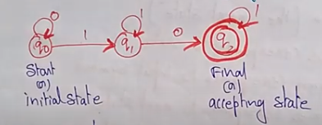

{0,1} are inputs

q0 – initial state

q1 – intermediate state

q2 – final state

* Tabular (Transition table)

It is basically a tabular representation of the transition function that takes two arguments (a state and a symbol) and returns a value (the next state).

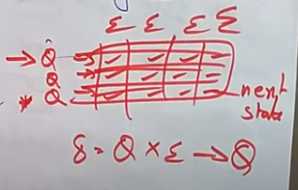

Rows corresponds to state

Column corresponds to the input symbols

Entries corresponds to next state

The start state is marked with an arrow( ->)

The accept state are marked with a star \*.

Ex: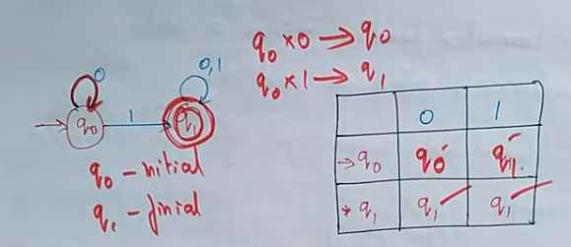

* Mathematical (Transition function or mapping function)

The mapping function or transition function denoted by δ.

Two parameters are passed to this transition function current state and input symbol.

The transition function returns a state which can be called as next state.

δ (current state, current input symbol) = next state

ex: δ(q0,a) = q1

or

δ(q0,1) = q1

* 1. Formal definition of a Finite Automaton

An automaton can be represented by a 5-tuple (Q, ∑, δ, q0, F), where −

* Q is a finite set of states.
* ∑ is a finite set of symbols, called the alphabet of the automaton.
* δ is the transition function (Q x ∑ -> Q).
* q0 is the initial state from where any input is processed (q0 ∈ Q).
* F is a set of final state/states of Q (F ⊆ Q).

1. Applications
   1. It plays an important role in compiler design.
   2. In switching theory and design and analysis of digital circuit automata theory is applied.
   3. Design & analysis of compiler software & hardware system.
   4. To prove correctness of the program automata theory is used.
   5. To design finite state machines such as more and melay machine
2. Types of finite automata

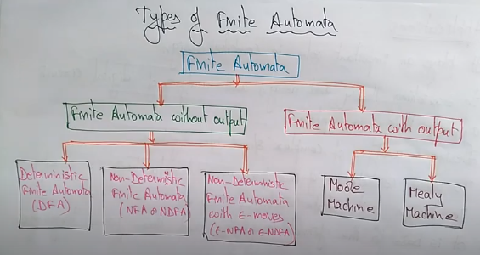

* 1. Deterministic finite automata (DFA)
     + The finite automata are called DFA if the machine reads an input string one symbol at a time.
     + Deterministic refers to the uniqueness of the computation.
     + In DFA, there is only one path for specific input form the current state to the next state.
     + DFA does not accept the null move i.e. DFA cannot change state without any input character.
     + DFA can contain multiple final states. It is used in lexical analysis in compiler.
     + Formal definition of DFA

Q is a finite set of states.

∑ is a finite set of symbols, called the alphabet of the automaton.

δ is the transition function (Q x ∑ -> Q).

q0 is the initial state from where any input is processed (q0 ∈ Q).

F is a set of final state/states of Q (F ⊆ Q).

* + - Graphical representation of DFA

The state is represented by vertices

The arc labeled with an input character show the transition

The initial state is marked with an arrow

The final state is denoted by a double circle.

* + - Ex: Find the transition diagram from the table

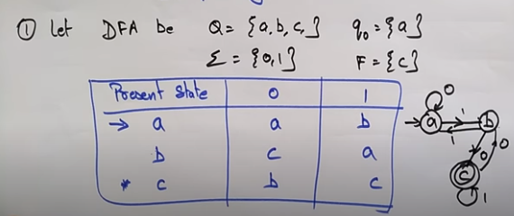

* + - Ex:

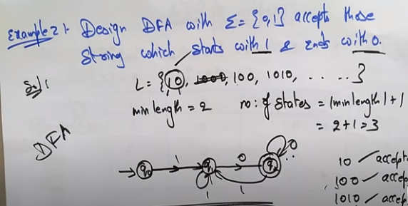

* + - Ex:

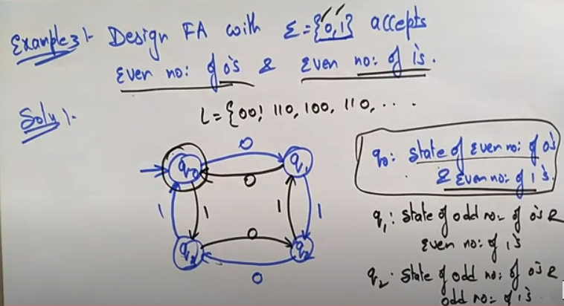

* + - Ex:

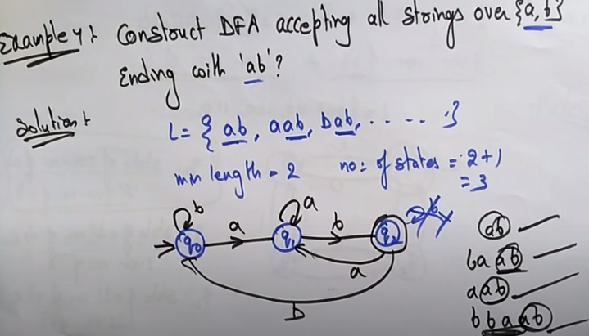

* 1. Non deterministic finite automata (NFA / NDFA)
     + The FA area called NFA when there exist many paths for specific input from the current state to the next state.
     + It is easy to construct NFA than DFA for the given regular language.
     + Every NFA is not DFA but each NFA can be translated into DFA.
     + NFA is defined in the same way as DFA but with two exceptions:

It contains multiple next state

It contains transitions

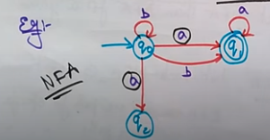

* + - Formal definition of NFA

An NDFA can be represented by a 5-tuple (Q, ∑, δ, q0, F) where −

Q is a finite set of states.

∑ is a finite set of symbols called the alphabets.

δ is the transition function where δ: Q × ∑ → 2Q

(Here the power set of Q (2Q) has been taken because in case of NDFA, from a state, transition can occur to any combination of Q states)

q0 is the initial state from where any input is processed (q0 ∈ Q).

F is a set of final state/states of Q (F ⊆ Q).

* + - Graphical representation of DFA

The state is represented by vertices

The arc labeled with an input character show the transition

The initial state is marked with an arrow

The final state is denoted by a double circle.

* + - Ex: Find the transition diagram from the table

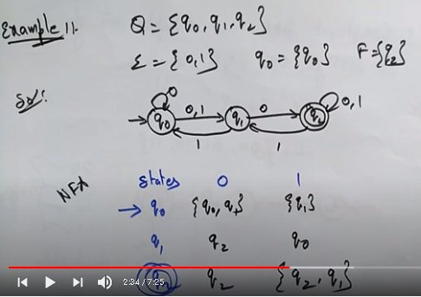

* + - Ex:

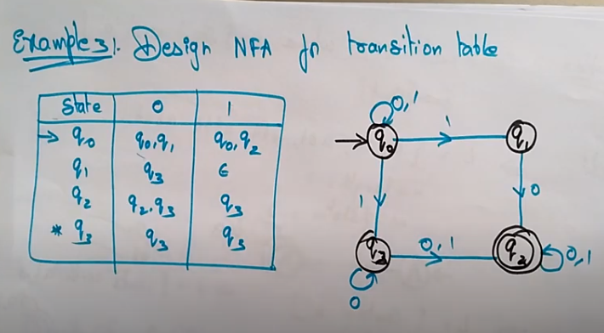

* + - Ex:

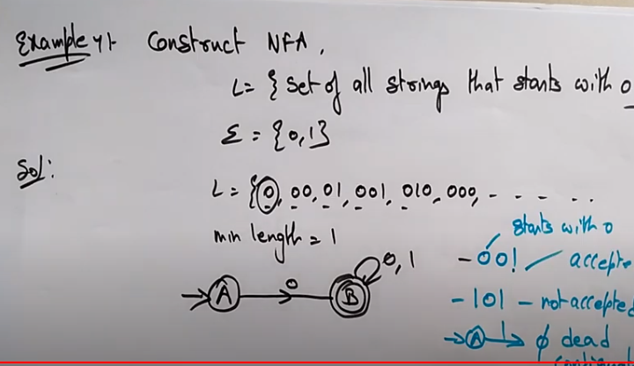

* + - Ex:

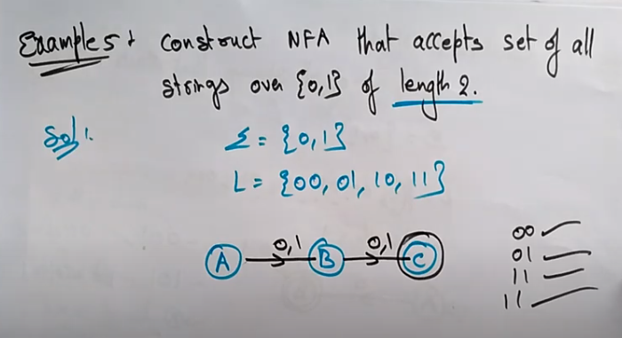

* 1. Mealy machine
     + A Mealy Machine is an FSM whose output depends on the present state as well as the present input.
     + It can be described by a 6 tuple (Q, ∑, O, δ, X, q0) where −

Q is a finite set of states.

∑ is a finite set of symbols called the input alphabet.

O is a finite set of symbols called the output alphabet.

δ is the input transition function where δ: Q × ∑ → Q

X is the output transition function where X: Q × ∑ → O

q0 is the initial state from where any input is processed (q0 ∈ Q).

* + - Ex:

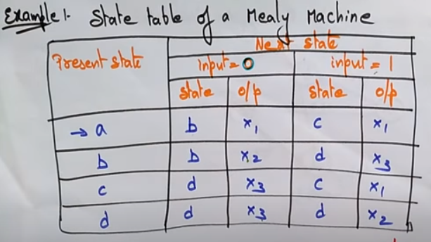

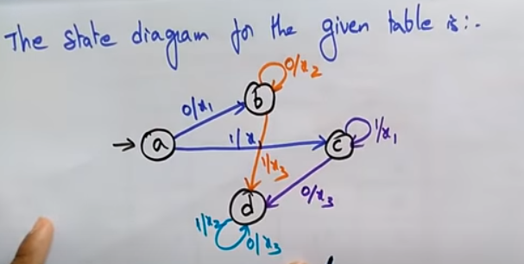

* + - Ex:

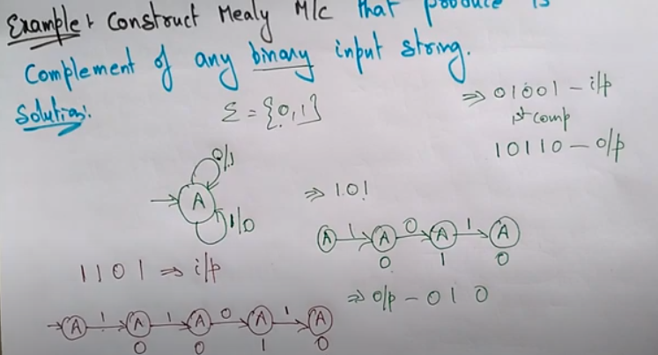

* + - Ex:

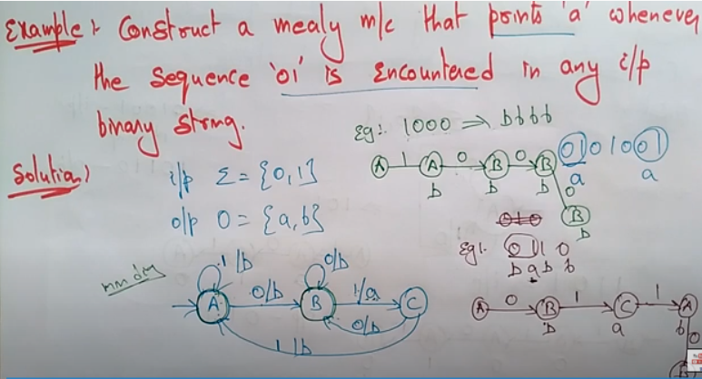

* + - Ex:

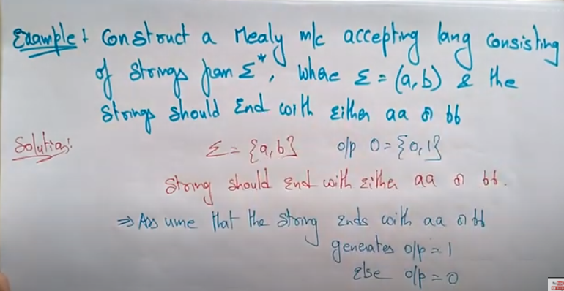

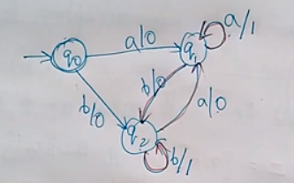

* 1. Moore machine
     + Moore machine is an FSM whose outputs depend on only the present state.
     + A Moore machine can be described by a 6 tuple (Q, ∑, O, δ, X, q0) where −

Q is a finite set of states.

∑ is a finite set of symbols called the input alphabet.

O is a finite set of symbols called the output alphabet.

δ is the input transition function where δ: Q × ∑ → Q

X is the output transition function where X: Q → O

q0 is the initial state from where any input is processed (q0 ∈ Q).

* + - Ex: Draw the state diagram using the table

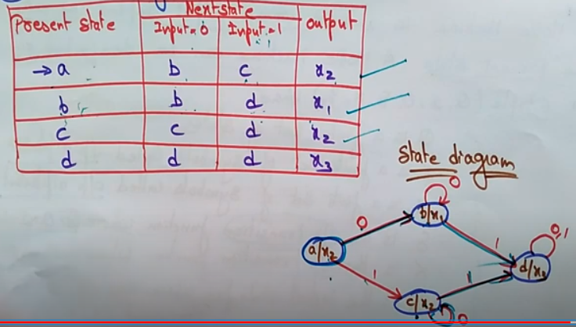

* + - Ex:

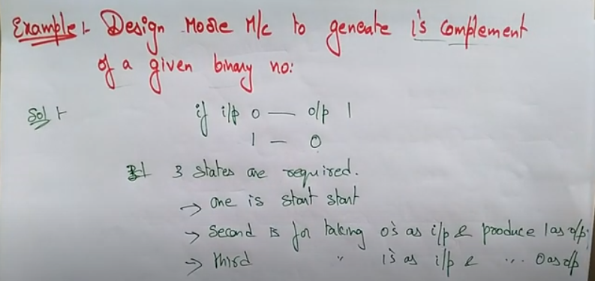

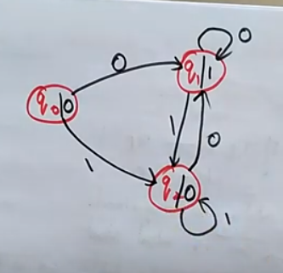

* + - Ex:

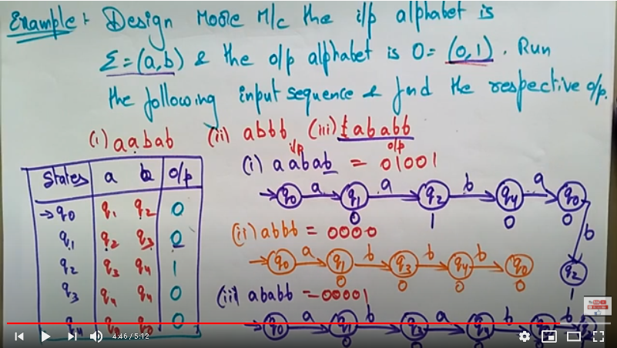

1. Mealy vs Moore machine

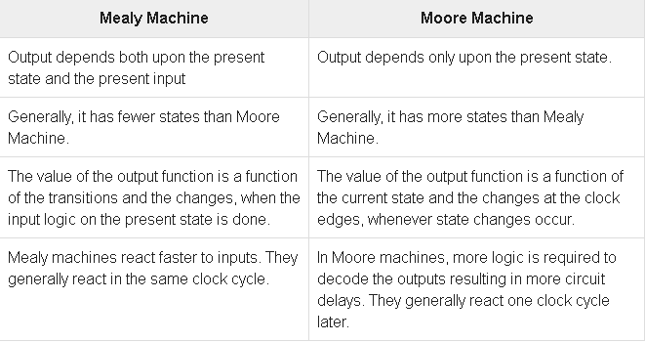

1. DFA vs NFA

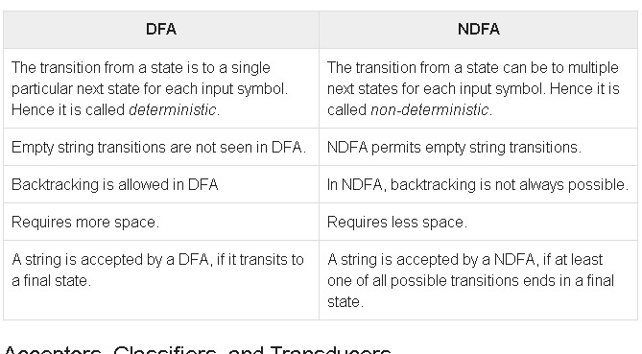

1. NFA to DFA conversion

Step 1 − Create state table from the given NDFA.

Step 2 − Create a blank state table under possible input alphabets for the equivalent DFA.

Step 3 − Mark the start state of the DFA by q0 (Same as the NDFA).

Step 4 − Find out the combination of States {Q0, Q1,... , Qn} for each possible input alphabet.

Step 5 − Each time we generate a new DFA state under the input alphabet columns, we have to apply step 4 again, otherwise go to step 6.

Step 6 − The states which contain any of the final states of the NDFA are the final states of the equivalent DFA.

Ex:

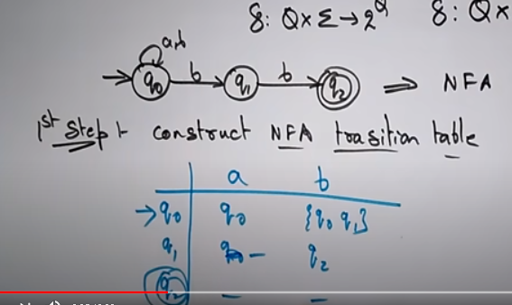

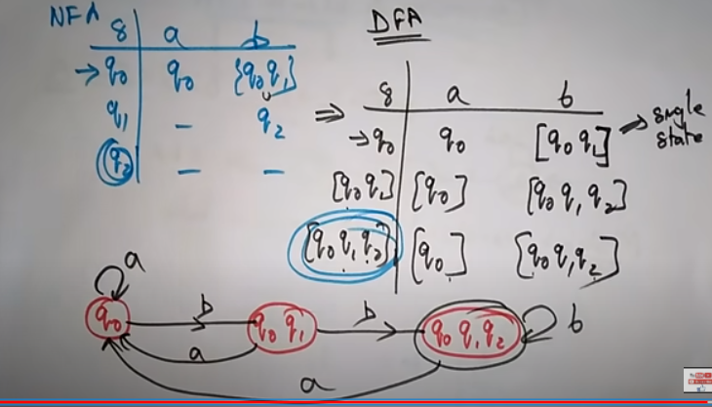

1. Equivalence of two finite automata

Step 1: For any pair of states (q1,q2) the transition for input a ∈ ∑ is defined by {qa,qb} where δ{qi,a}=qa and δ {aj,a}=qb , the two automata are not equivalent if for a pair {qa,qb} one is intermediate state & other is final state.

Step 2: If the initial state is final state of one automata then the second automata also initial state must be final state for them to be qivalent.

Ex:

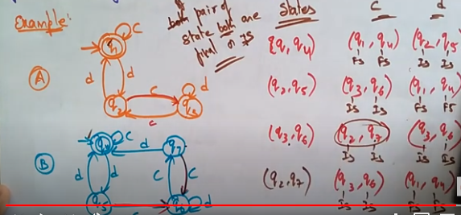

Ex:

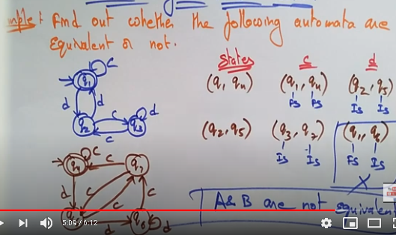

1. Minimization of DFA

The minimization DFA means reducing the number of states from a given FA.

* + - * 1. Using equivalence theorem

Step1 : Remove all the states that are unreachable form the initial state via any set of transition of DFA.

Step2 : Draw the transition table for all pair of states.

Step 3: Now split the transiton table into two tables T1 & T2

T1 contains all final states

T2 contains non-final states

Step4 : Find similar rows from T1 such that

δ (q,a)= P

δ (r,a)=P

i.e find the two states which have same value of a & b and remove one of them.

Step5 : Repeat step 3 untill we find no si,ilar rows available in T1.

Step6 : Repeat step 3 and step 4 for table T2 also.

Step7 : Now combine the reduced T1 and T2 tables i.e. the final transition table of minimized DFA.

Ex:

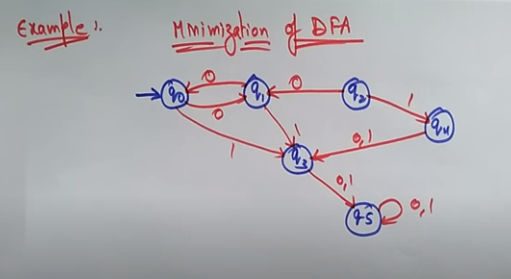

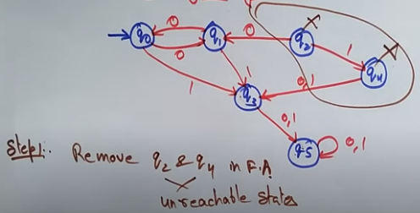

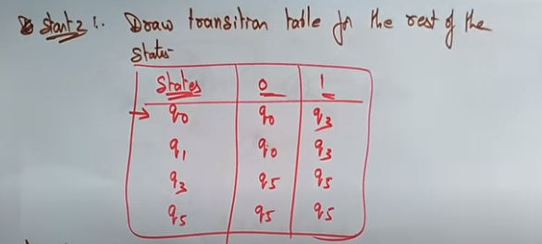

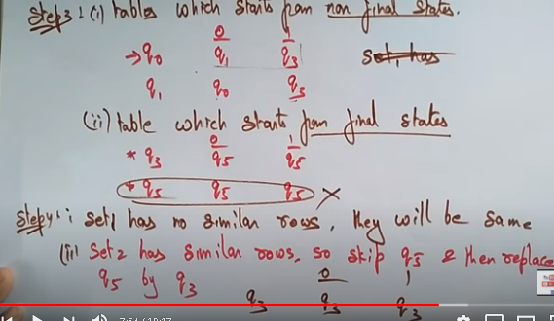

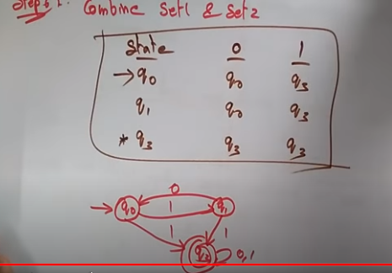

1. Mealy to Moore conversion

Input − Mealy Machine

Output − Moore Machine

Step 1 − Calculate the number of different outputs for each state (Qi) that are available in the state table of the Mealy machine.

Step 2 − If all the outputs of Qi are same, copy state Qi. If it has n distinct outputs, break Qi into n states as Qin where n = 0, 1, 2.......

Step 3 − If the output of the initial state is 1, insert a new initial state at the beginning which gives 0 output.

Ex:

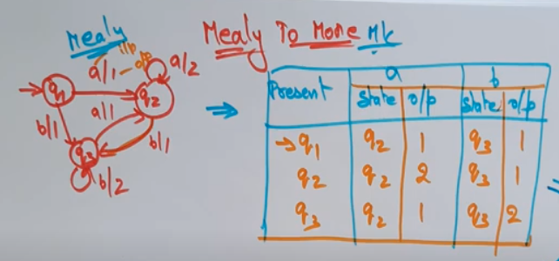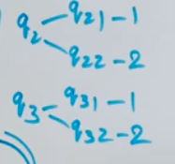

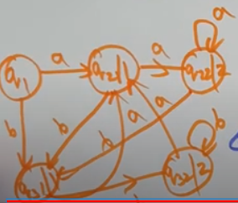 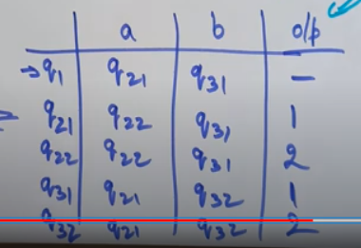

1. Moore Machine to Mealy Machine

The length of Moore machine is one less than the Mealy machine.

Input − Moore Machine

Output − Mealy Machine

Step 1 − Take a blank Mealy Machine transition table format.

Step 2 − Copy all the Moore Machine transition states into this table format.

Step 3 − Check the present states and their corresponding outputs in the Moore Machine state table; if for a state Qi output is m, copy it into the output columns of the Mealy Machine state table wherever Qi appears in the next state.

Ex:

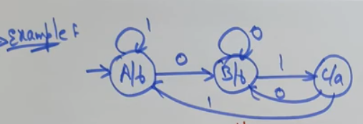

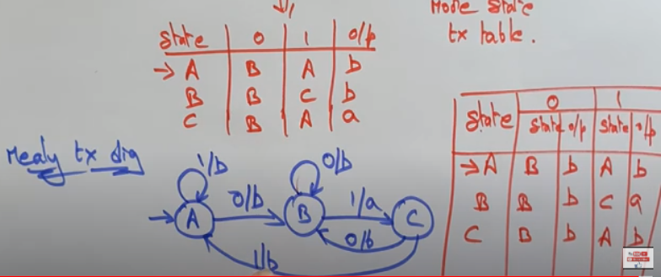

Ex:

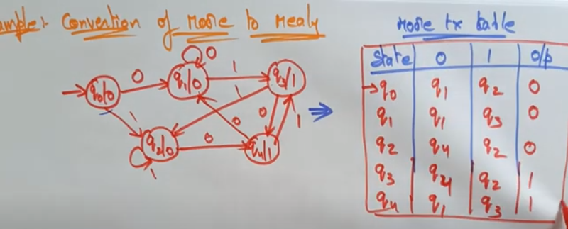

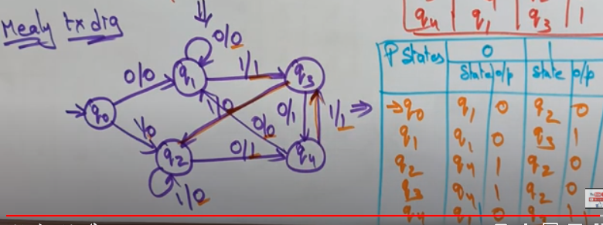

Ex:

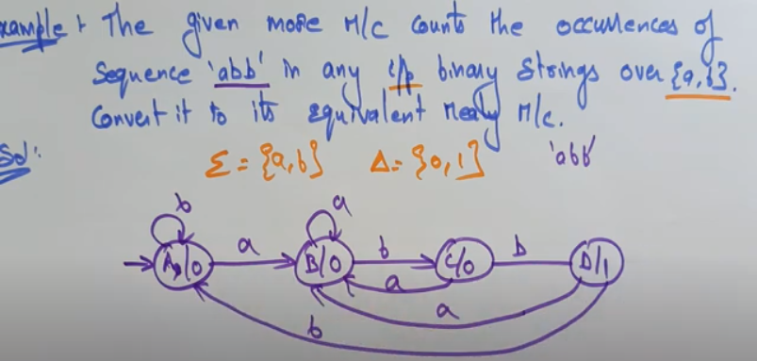

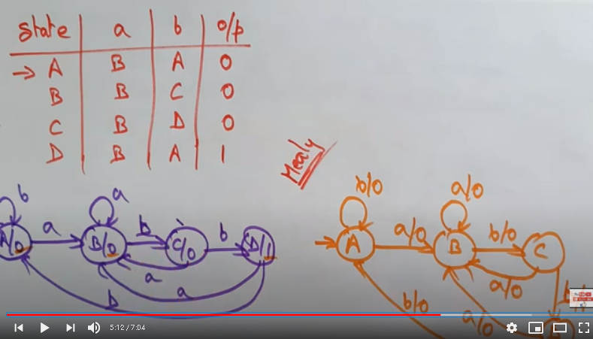

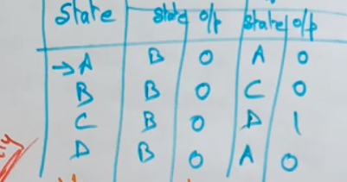

1. Regular expression

* The language accepted by finite automata can easily describe by simple expression called Regular expression.
* The language accepted by some regular expression are referred to as Regular languages.
* A regular expression can also be described as a sequence of pattern that defines a string.
* A Regular Expression can be recursively defined as follows −
  + - ε is a Regular Expression indicates the language containing an empty string. (L (ε) = {ε})
    - φ is a Regular Expression denoting an empty language. (L (φ) = { })
    - x is a Regular Expression where L = {x}
    - If X is a Regular Expression denoting the language L(X) and Y is a Regular Expression denoting the language L(Y), then
    - X + Y is a Regular Expression corresponding to the language L(X) ∪ L(Y) where L(X+Y) = L(X) ∪ L(Y).
    - X . Y is a Regular Expression corresponding to the language L(X) . L(Y) where L(X.Y) = L(X) . L(Y)
    - R\* is a Regular Expression corresponding to the language L(R\*)where L(R\*) = (L(R))\*
* Ex:

